# CONCISE CHESS

## Contents

* Introduction
* Getting to Know the Chessboard
* Getting to Know the Pieces
* Check and Checkmate
* Castling, Pawn Promotion and En Passant
* Chess Notation
* How the Game Ends
* Checkmating Methods and Patterns
* Attacking and Defending Pieces
* Tactics
* Opening Play
* Thinking Ahead
* What to do Next

## INTRODUCTION

* This book is exactly as the title says, it’s simple and concise, but it possibly covers everything needed to start
* it doesn’t need any prior knowledge
* the level of difficulty rises by the chapter

### FASCINATION

* Practice is generally rewarded, and improvement can be easily gauged by results
* the game could be quite addictive
* and it doesn’t require an element of luck
* chess isn’t something you’d have to retire from

### HOW THE GAME IS PLAYED

* There are 64 squares on a board
* each player has 16 pieces, so 32 in general
* the aim of the game is to trap your enemy’s king (checkmate)
* in competitive games a chess clock is used, it isn’t compulsary in friendlies
* if your alloted time runs out while you’re losing in material you lose

# CHAPTER ONE

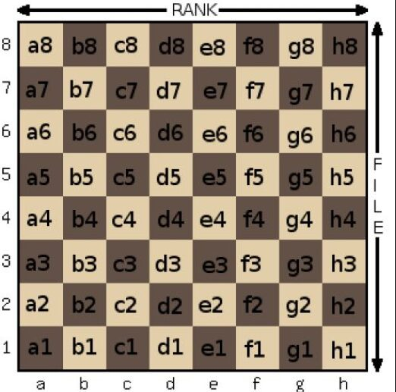

## GETTING TO KNOW THE CHESS BOARD

* It comprises of 64 squares
* We’d refer to the squares as light and dark squares, and the pieces as white and black

### The Board and Its Coordinates

* The squares at the bottom right and top left are always light squares; so h1 and a8 are light squares
* conversely the squares at the bottom left and top right are dark squares; so a1 and h8 are dark squares
* The numbers and letters at the sides and bottom are a coordinate system that acts as a reference map when discussing individual squares.
* The normal convention is to show the board from white’s point of view, White plays up the board
* odd and odd / even and even are dark squares
* odd and even / even and odd are light squares

### Ranks and Files

* the lines of squares going horizontally are known as ranks.
* the lines of squares travelling vertically are known as files.

### Sectors of the Board

* For descriptive purposes the board is shared into two halves; Looking from white’s point of view (So it should be the opposite from black’s point of view)
  + the left side (a, b, c , and d files) is known as the queen’s side
  + the right side (e, f, g, and h files) is known as the king’s side
* always be conscious of how big the board is, so in essence always be conscious of the boundaries of the board and how close or far you are from them, there are also other important areas to keep an eye for that should also help for better coordination, like the center squates and others i should learn down the line.
* All squares on the 1st rank, 8th rank, the entirety of the a file, and the entirety of the h file make the boundaries of the board

# CHAPTER TWO

## Getting to Know the Pieces

### Introducing the Rook

* This is the easiest piece to understand
* castle is an improper name for the look
* The rook moves horizontally and vertically
* For visualization purposes: a rook on d4 can access;
  + vertically; d1 through d8
  + horizontally; a4 through h4

so vertically the letters stay constant, while horizontally the numbers stay constant

* it captures in the same way that it moves

### **Introducing the Bishop**

* It’s a tall piece, and it’s top is shaped like a mitre
* it moves diagonally in any direction
* using the square the bishop is as an origin point(know what color of a square it’s on so you know what options are available to you), calculate how many files are left to both sides of the bishop and cross reference it to possible important locations, also check other important facts about it’s location like what color of a square is it on and the possible boundary squares available to it , should help with better visualization on how far it could go .e.g. a bishop on f4
* it captures in the same way that it moves

#### The Two Bishops

* Each player begins the game with two bishops
* one operates on the light squares, while the other operates on the dark squares
* A bishop on it’s own only has the potential to cover half the board, whilst a pair has the potential to cover the whole board

### **Introducing the Queen**

* The queen is the second tallest piece on the board (second only to the king)
* with a crown at it’s top
* the queen combines the powers of the rook and the bishop, so it can move in all possible directions, so once comfortable with the visualization of the rook and bishop combine their powers
* it captures in the same way that it moves

### Introducing the King

* The king is the most important piece on the board
* it’s also the tallest piece
* it has a cross at it’s top
* it moves one square at a time in any direction
* it also captures in the same way as it moves

### Introducing the Pawn

* The pawn is the lowiest and smallest of the pieces
* each player begins with 8 pawns on either the 2nd or 7th ranks
* pawns move vertically (but only forward and not backwards)
* they move one step at a time, except on the 1st move when they have the option of moving 1 or 2 squares
* it doesn’t capture in the same way that it moves, rather it captures only one square diagonally forward, even on the first move

### Introducing the Knight

* A knight not on the edge, and not blocked by a piece of it’s own, has access to a total of 8 squares, e.g. a knight on d4
* it moves in an L shape
* it can jump over it’s own pieces, and enemy pieces in it’s path
* it can access the immediate 2 files and 2 ranks around it, so a general of 4 ranks and 4 files
  + for the immediate files around it, it moves by 2 ranks
  + for the immediate ranks around it, it moves by 2 filess
  + so a knight on f5 can reach d4, d6, e3, e7, g3, g7, h4, h6
  + so it can access 2 squares on the same rank, and 2 squares on the same file
* it captures in the exact same way it moves
* if the knight begins on a light or dark colored square it always ends on a square of the opposite color

### The Pieces: A Summary

* The queen and rook are the most powerful pieces and are known as the major pieces
* the bishop and knight are of similar strength and are known as minor pieces
* the pawns are the weakest pieces on the board but they make up for it in numbers, and can also be promoted
* the king is a relatively weak piece but also the most valuable piece on the board
* in their starting position, the queen is always on a square of the same colour
* the unit of measurement for chess is moves, so always pay attention to how many moves needed to checkmate/stalemate, how many moves available in a certain position, how many moves it took to play a game...
* On an open board the rook always has 14 possible moves available, regardless of where it is positoned
* this is a note, not a new textbook, the most important thing to note are key facts and ideas

# CHAPTER THREE

## CHECK AND CHECKMATE